Automate AWS Resource Provisioning

Project Description
This project demonstrates AWS infrastructure automation using Python boto3 library. The main objective is to eliminate manual AWS console operations by automating the creation of IAM users, S3 buckets, and EC2 instances using Python scripts.
The project provides hands-on experience with cloud automation, AWS SDK integration, and basic Infrastructure as Code (IaC) principles. It helps in understanding how cloud resources can be programmatically managed in real-world DevOps environments.

IAM_user_creation.png
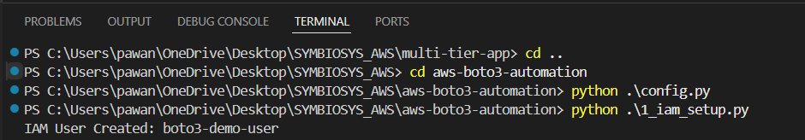

S3_bucket_creation.png

EC2_launch.png
EC2_dashboard.png
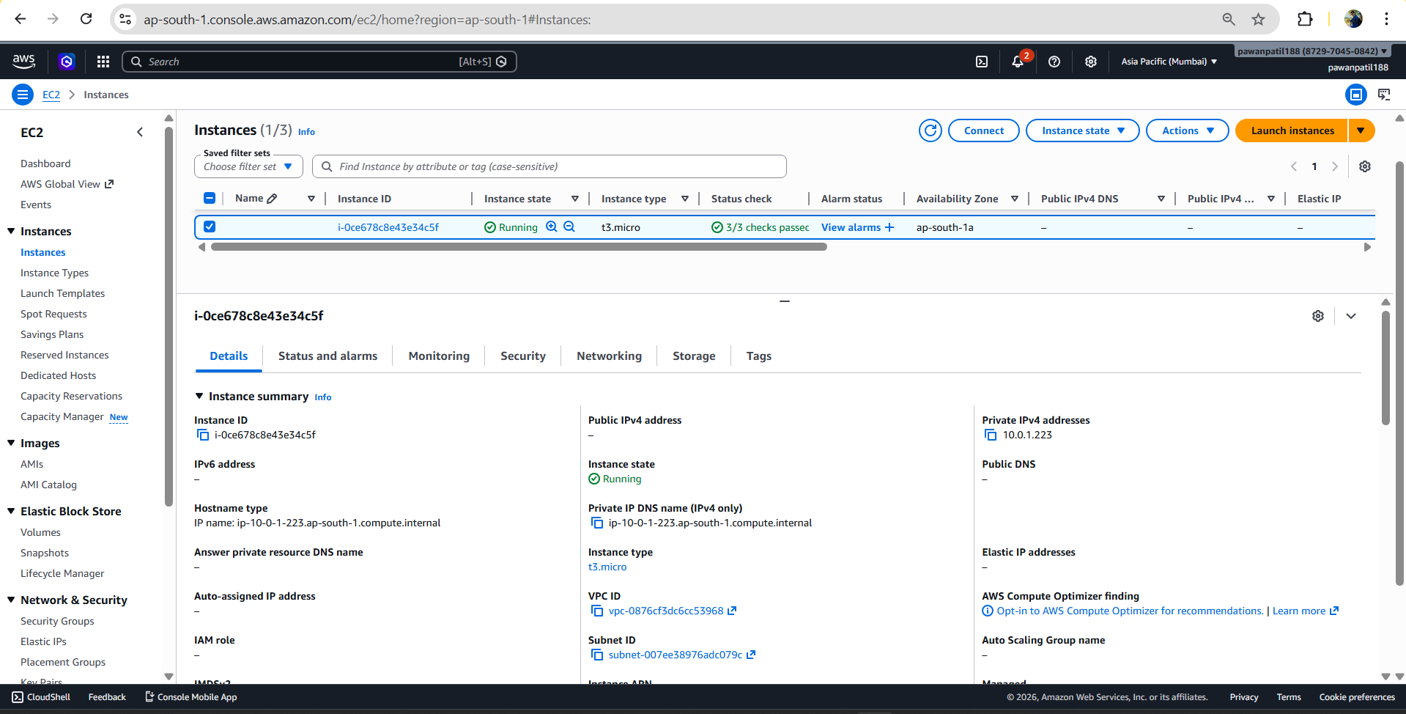

S3_dashboard.png
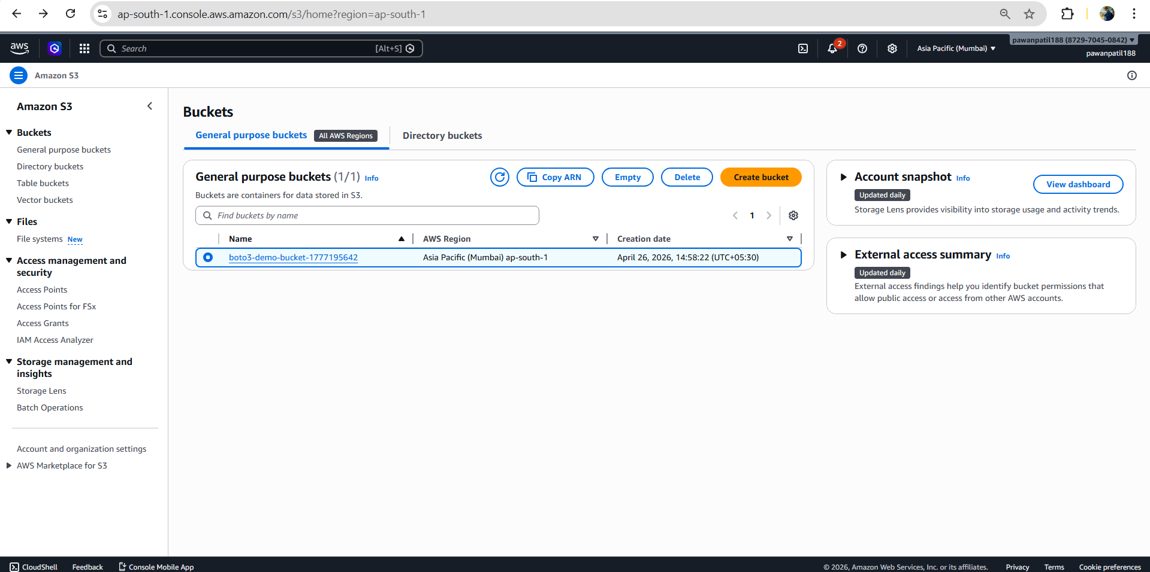

IAM _dashboard.png

